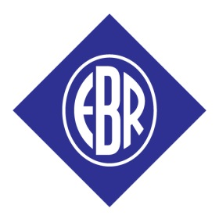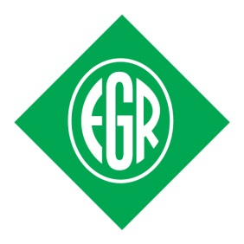
Rallies NI - Uniform Order Form

Rally:
Name:
Contact Details:
Special Instructions:

Orders can be sent to Rally Supplies, Crescent Church, 6 University Road, Belfast, BT7 1NH or by email to info@ralliesni.com.

Please make cheque payable to RALLY SUPPLIES N. IRELAND.

Orders are usually made up on Wednesday afternoons, mid-September through to Easter, except during school holidays. Orders can be collected from the Crescent Church office, which is normally open from Tuesday – Friday, 10:00am – 4:00pm. You can telephone 028 9024 4026 to check if your order is ready.

Prices from September 2015.

ITEM: | PRICE PER ITEM: | SIZE, COLOUR AND  QUANTITY REQUIRED: | TOTAL PRICE:
UNIFORM
Sweatshirts 4-12 years | £10.50
Sweatshirts S, M, L, XL and XXL | £16.00
Polo shirts 4-12 years | £9.50
Polo shirts S, M, L, XL and XXL | £12.00
Tracksuit joggers 5-12 years | £10.00
Tracksuit joggers S, M, L, XL and XXL | £13.50
Jersey Joggers 3-4 years and 5-6 years | £9.00

ITEM: | PRICE PER ITEM: | SIZE, COLOUR AND  QUANTITY REQUIRED: | TOTAL PRICE:
SPARROWS / TINY TOTS / EARLY YEARS
Enrolment badge | £2.00
Group badge | £0.40
Gold and silver stars | £0.60
Coloured stars | £0.50
Certificate | £0.20
JUNIORS
Metal badge | £2.50
Group badge | £0.60
Proficiency badge | £0.60
Efficiency & star badges | £0.60
Step & beginner | £0.60
Certificate | £0.20
Group leader’s cord | £0.40
Assistant group leader’s cord | £0.30
SENIORS
Metal badge | £2.00
Group badge | £0.50
Proficiency badge | £0.60
Certificate | £0.20
EBR
Enrolment badge | £0.50
CADETS
Badge | £0.60
Certificate | £1.00
Manual | £5.00
AWARDS
Gold, silver and bronze award badges | £3.00
Gold, silver and bronze award certificate | £0.50
OTHER
EGR/EGR Centres | £0.80
Gold coloured metal badge for centres | £2.00
Green and red Petersham per metre | £1.30
TOTAL PRICE |  | £

